Sao Tome and Principe

## GNI per capita and development level

The data set shows the GNI per capita and development level of the country each year.

## # A tibble: 19 x 5  
## country iso3c date GNIperCapita devCategory   
## <chr> <chr> <dbl> <dbl> <chr>   
## 1 Sao Tome and Principe STP 1996 1056. Lower Middle Income  
## 2 Sao Tome and Principe STP 1998 4881. Upper Middle Income  
## 3 Sao Tome and Principe STP 2000 654. Low Income   
## 4 Sao Tome and Principe STP 2002 2030. Lower Middle Income  
## 5 Sao Tome and Principe STP 2003 1969. Lower Middle Income  
## 6 Sao Tome and Principe STP 2004 1880. Lower Middle Income  
## 7 Sao Tome and Principe STP 2005 1582. Lower Middle Income  
## 8 Sao Tome and Principe STP 2006 2295. Lower Middle Income  
## 9 Sao Tome and Principe STP 2007 2241. Lower Middle Income  
## 10 Sao Tome and Principe STP 2008 1955. Lower Middle Income  
## 11 Sao Tome and Principe STP 2009 1955. Lower Middle Income  
## 12 Sao Tome and Principe STP 2010 1094. Lower Middle Income  
## 13 Sao Tome and Principe STP 2011 2257. Lower Middle Income  
## 14 Sao Tome and Principe STP 2012 3118. Lower Middle Income  
## 15 Sao Tome and Principe STP 2013 2657. Lower Middle Income  
## 16 Sao Tome and Principe STP 2014 2870. Lower Middle Income  
## 17 Sao Tome and Principe STP 2015 2870. Lower Middle Income  
## 18 Sao Tome and Principe STP 2016 2718. Lower Middle Income  
## 19 Sao Tome and Principe STP 2017 5006. Upper Middle Income

## GDP growth and economic growth classification

The data set shows the GDP growth and the ecomic growth classification of the country each year.

## # A tibble: 19 x 5  
## country iso3c date GDPannualGrowthRate GDPgrowthCategory4  
## <chr> <chr> <dbl> <dbl> <fct>   
## 1 Sao Tome and Principe STP 1996 6.93 fast growth   
## 2 Sao Tome and Principe STP 1998 1.54 slow growth   
## 3 Sao Tome and Principe STP 2000 3.34 moderate growth   
## 4 Sao Tome and Principe STP 2002 2.38 slow growth   
## 5 Sao Tome and Principe STP 2003 6.57 fast growth   
## 6 Sao Tome and Principe STP 2004 3.83 moderate growth   
## 7 Sao Tome and Principe STP 2005 7.09 fast growth   
## 8 Sao Tome and Principe STP 2006 9.12 fast growth   
## 9 Sao Tome and Principe STP 2007 3.25 moderate growth   
## 10 Sao Tome and Principe STP 2008 8.19 fast growth   
## 11 Sao Tome and Principe STP 2009 2.43 slow growth   
## 12 Sao Tome and Principe STP 2010 6.67 fast growth   
## 13 Sao Tome and Principe STP 2011 4.40 moderate growth   
## 14 Sao Tome and Principe STP 2012 3.14 moderate growth   
## 15 Sao Tome and Principe STP 2013 4.81 moderate growth   
## 16 Sao Tome and Principe STP 2014 6.55 fast growth   
## 17 Sao Tome and Principe STP 2015 3.91 moderate growth   
## 18 Sao Tome and Principe STP 2016 4.16 moderate growth   
## 19 Sao Tome and Principe STP 2017 3.85 moderate growth

## Development trend

The plot shows the development trend of the country.

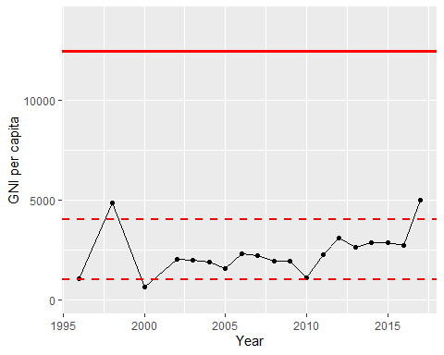

GNI Per Capita Trend